Assignment--4

Date : November 3, 2022

Team ID PNT2022TMID34745

Project Name Industry-Specific Intelligent fire

management system

Maximum Marks 2 Marks

Question:

Write code and connections in wokwi for the ultrasonic sensor. Whenever the

distance is less than 100 cms send an "alert" to the IBM cloud and display in

the device recent events.

Wokwi link:

https://wokwi.com/projects/347294151283311187

Code:

const int TRIG_PIN = 7;

const int ECHO_PIN = 8;

//anything over 400cm(23200 us pulse)is "out of range"

const unsigned int MAX_DIST = 23200;

void setup() {

//The Trigger pin will tell the sensor to range find

pinMode(TRIG_PIN, OUTPUT);

digitalWrite(TRIG_PIN, LOW);

//Set Echo pin as input to measure the duration of pulse coming back from the

//distance sensor

pinMode(ECHO_PIN, INPUT);

//We'll use the serial monitor to view the sensor output

Serial.begin(9600);

}

void loop() {

unsigned long t1;

unsigned long t2;

unsigned long pulse_width;

float cm;

float inches;

//Hold the trigger pin high for at least 10us

digitalWrite(TRIG_PIN, HIGH);

delayMicroseconds(10);

digitalWrite(TRIG_PIN, LOW);

//wait for pulse on echo pin

while (digitalRead(ECHO_PIN) == 0);

//Measure how long the echo pin was held high (pulse width)

//note the micros()counter will overflow after -70min

t1 = micros();

while (digitalRead(ECHO_PIN) == 1);

t2 = micros();

pulse_width = t2 -t1;

//calculate distance in centimeters and inches. The constantsare found in

//datasheet,and calculated from the assumed speed of sound in air at

sealevel(-340m/s)

cm = pulse_width / 58;

inches = pulse_width / 148.0;

//print out results

if (pulse_width > MAX_DIST) { > MAX_DIST) {

Serial.println("Out of range");

}

else

{

Serial.println("**********");

Serial. println("The Measured Distance in cm:");

Serial.println(cm);

if (cm < 100)

{

//while (true)

{

Serial.println("Alert!");

}

}

Serial.println("**********");

}

//wait at least 1000ms before next measurement

delay(1000);

}

Case 1: If the Distance less than 100 cms it will Alertase 1: If the Distance less than 100 cms it will Alert.

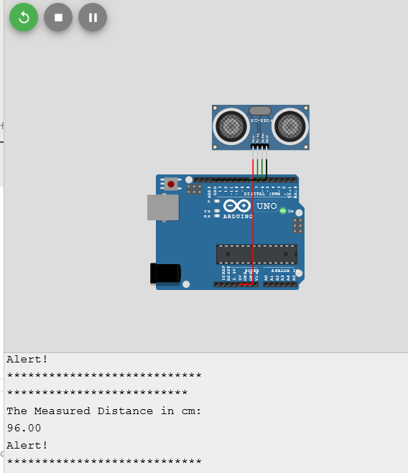

Case 2: If the Distance greater than 100 cms it wont Alert.

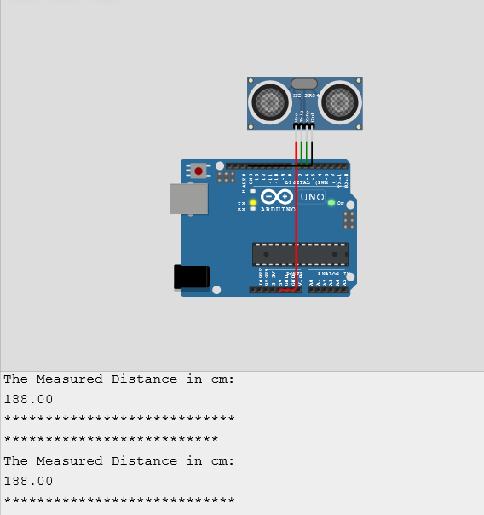

Case 3: If the distance is beyond the limit it will display Out Of Rangease 3: If the distance is beyond the limit it will display Out Of Range.

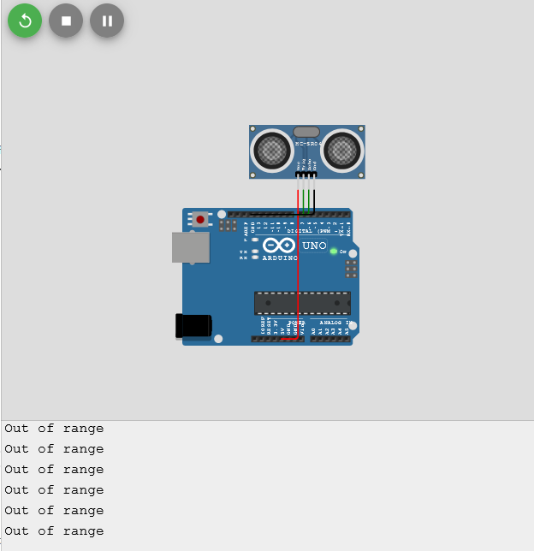

Circuit:

